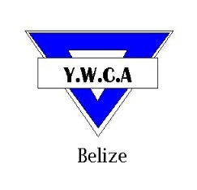
YOUNG WOMEN’S CHRISTIAN ASSOCIATION
Cor. Freetown Road and St Thomas Street
Belize City, Belize C.A.
Tel: 203-4971 * Fax: 223-5685
Email:bzeywca@yahoo.com * Website: www.ywcabelize.com
Check us out on Facebook: YWCA-BELIZE
SUMMER PROGRAMMEREGISTRATION FORM

Name: ______________________________________________________________ Sex: F M
Address: ______________________________________________________________ Age (D/M/Y): ________________
Phone (home): ____________________ Phone (work): ______________ Phone (cell): ________________
Parent/ Guardian Name: __________________________________________________ Email: ________________________
(To be completed if applicant is age 16 or under)
Educational Background & Additional Information:

Class Child is promoted to for September 2012: ___________________________________________________________________________

Please check the Programme(s) for which you are registering:

Computer |  | Day Care
Pre-school |  | Arts & Craft
Math & English |  | Cosmetology
Reading |  | Cake & Pastry Making
Cooking |  | Housekeeping
Cake Decorating |  | Volleyball
Basketball |  | Karate
Sign Language |  | Fitness Camp (Teens)
Environmental Tour |  | Fitness Camp (Adults)
________________________________ _______________________________________________
Signature (signature of parent / guardian if child is age 16 or under) Contact Number (parent/ Guardian)

For administration use only:
Amount Paid: ______________________________ Date Paid: ______________________________
Authorized Signature: _________________________________________________________________________________________________________________

