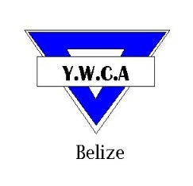
YOUNG WOMEN’S CHRISTIAN ASSOCIATION
Cor. Freetown Road and St Thomas Street
Belize City, Belize C.A.
Tel: 203-4971 * Fax: 223-5685
Email:bzeywca@yahoo.com * Website: www.ywcabelize.com
Check us out on Facebook: YWCA-BELIZE
YWCA FITNESS INSTRUCTOR FORM

Name: ______________________________________________________________ Sex: F M
Address: ______________________________________________________________ Age (D/M/Y): ________________
Phone (home): ____________________ Phone (work): ______________Phone (cell): ________________
Area of Specialty: ________________________________________________________ Occupation: ________________
Session: ( ) July 2nd-July 20th, 2012 ( ) July 23th- August 11th, 2012
Time: ( ) 4:15 pm- 5:15 pm ( ) 5:30pm – 6:30 pm
- Classes are Mondays, Tuesdays, Wednesday, and Thursday @ 4:15pm & 5:30pm.
- Mondays (Taebo/ Aerobics), Tuesday (Cardio), Wednesday (Karate/kickboxing), Thursday (Water Aerobics/Zumba)
- Incentives are given for the Biggest Weekly/ Monthly/ Overall (Weight) Loser

…………………………………………………………………………………………………………………………………………………………………………………………
Disclaimer:
I agree to partake by training participants attending the Fitness Programme. I agree to operate in a professional manner and to abide by rules of the institution.

__________________________ ____________________________________ _________________________________________
Signature Witness Date
………………………………………………………………………………………………………………………………………………………………………………………………

