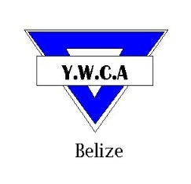
YOUNG WOMEN’S CHRISTIAN ASSOCIATION
Cor. Freetown Road and St Thomas Street
Belize City, Belize C.A.
Tel: 203-4971 * Fax: 223-5685
Email:bzeywca@yahoo.com * Website: www.ywcabelize.com
Check us out on Facebook: YWCA-BELIZE
SUMMER PROGRAMME
VOLUNTEER APPLICATION FORM

Name: ______________________________________________________________ Sex: F M
Address: ______________________________________________________________ Age (D/M/Y): __________________
Phone (home): ____________________ Phone (work/school): ______________ Phone (cell): ___________________
Parent/ Guardian Name: _____________________________________________________Email: ___________________________
(To be completed if applicant is age 16 or under)
Educational Background:

REFERRING INSTITUTION: _______________________CONTACT PERSON: ______________________ CONTACT #:______________

Have you worked with YWCA before? YES NO Programme& YEAR: ___________________________
____________________________________________________________________________________________________________________________________

Please check the Programme(s) below:

Computer |  | Day Care
Pre-school |  | Arts & Craft
Math & English |  | Cosmetology
Reading |  | Cake & Pastry Making
Cooking |  | Housekeeping
Cake Decorating |  | Volleyball
Basketball |  | Karate
Sign Language |  | Swimming *
Environmental Tour |  | Social Graces & Etiquette

- For swimming please list any relevant certificates you have:___________________________________________
When are you available to work? (Please check all that apply)
( ) July: Morning Afternoon
( ) August: Morning Afternoon

